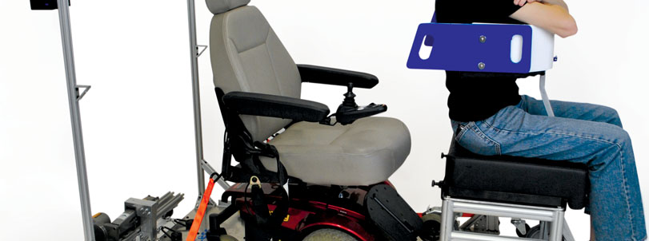

**Redesigning the Flying Experience for Passengers with Limited Mobility**

Mechanical Engineering 310 Final Report

Team Embraer

Rodrigo Monteiro, Clifford Bargar, Maria Barrera, Luiz Durão,

Laura Hoinville, Guilherme Kok, Amanda Mota

Mechanical Engineering Design Group

416 Escondido Mall

Stanford University

Stanford, CA 94305-2203

http://me310.stanford.edu

June 10th, 2014